Table of Contents

1. INTRODUCTION TO GHORKHA HYDRO AND ENGINEERING PVT. LTD. 2
2. COMPANY'S BIOGRAPHY 2
3. WORKING FIELDS AND SERVICES 3
4. EQUIPMENT AND OTHER FACILITIES 3
5. OFFICE ACCOMMODATION 4
6. LIST OF PROJECT 7
6.1 Ongoing Projects 7
6.2. Completed Projects 8
7. ORGANIZATIONAL STRUCTURE OF THE COMPANY 10
8. ORGANIZATIONAL CHART 11
9. KEY PERSONNEL WITH THEIR ACADEMIC QUALIFICATION AND YEAR OF EXPERIENCE 12
10. LOCATION MAP OF OFFICE: 13
ANNEXE-I (Company Registration Certificate) 14
ANNEXE-II VAT Registration Certificate 15

1. INTRODUCTION TO GHORKHA HYDRO AND ENGINEERING PVT. LTD.

GORKHA HYDRO AND ENGINEERING PVT. LTD. (GHE) is a cohesive group of professionals in the field of Multi-Disciplinary Engineering Service Providing Consultancy established in December 2011 to serve the expertise for the various development activities of nation. The major services of the company includes hydropower development, pre-feasibility, feasibility study, detailed survey, design, estimate, project preparation and implementation, geological and geotechnical study, ground water investigation, structural and architectural design, socio-economic and environmental study, human resource development, software development etc.

This company has full time staffs consisting of managers, planners, designers, engineers, estimators, surveyors, geologists, computer engineers, system analysts, programmers, contract specialists, insurance experts, software developers, junior technicians and administrative staff. The company has part time staff in various disciplines such as project preparation, detail engineering, agricultural forestry, environmental science, social mobilization, construction, and commissioning. Further it has number of professionals, who are available for the consultation as and when required to render the better services to the satisfaction of the client.

The company is an organization of highly experienced personnel as well as young, energetic, skilful and dedicated professionals with wide range of expertise. It is capable of combining different talents to achieve a smooth on time performance and achieve a goal of complete satisfaction of clients.

The company is fully aware of its services towards nation. Its ultimate goal is to participate for the nation's development by offering excellent multidisciplinary services required for the developing country.

2. COMPANY'S BIOGRAPHY

Company was legally registered in Mangsir, 2068 B.S.( December 2011) under the company act of
2053 B.S. to Department of Industries.

Company Name : Gorkha Hydro and Engineering Pvt. Ltd. Established : Mangsir 2068 B.S. (December 2011) Registration No. : 88804/068/069
VAT Registration No. : 600 387 835
Head Office : Baneswor, Kathmandu Working Office : Narephant, Kathmandu. P.O.Box : 2953
Authorized Capital : NRs. 1,00,00,000/- Issued Capital : NRs. 50,00,000/-

3. WORKING FIELDS AND SERVICES

This company is mainly intended to work in the field of hydropower development sector, all kinds of Civil and Architectural Engineering as well as all other sectors. Besides this, the company has tried to give consulting services in all the surveying, engineering, planning and construction fields. The following are the fields through which the company is going to serve:

• Hydropower Development & Rural Electrification Works
• Highway and Transportation including Trail Bridges
• Surveying, Designing and Preparing Drawings
• Water resources management, Hydraulic Design, Irrigation and Hydrology
• Structural and architectural design
• Water supply and sanitation
• Electrical and mechanical engineering
• Construction management and construction
• Human resources development through Trainings
• Urban planning & housing development
• Software development and Computer Training
• Quality Control Computer Training
• Pre-feasibility and feasibility Study
• Project Planning, Cost Estimation and budgeting
• Tender preparation and contract management
• Production & Cost control
• Insurance and Quantity Survey
• Valuation
• Geological and geo-technical study
• Socio-economic and environmental study
• Agriculture and forestry study.
• Supply and Installation of Electro-Mechanical Equipments

4. EQUIPMENT AND OTHER FACILITIES
GHE PVT. LTD. is a hydropower developer, engineering consultancy, computer software developer, and planner and well equipped with logistic support and the necessary equipment. The description of the equipment and facilities it would offer are given below.

• Desktop Computer  • Lap Top Computer | P-IV  i3, i5 |  |  |  | 2 Sets  17 Sets
• Plotter  • Printer  • Printer  • Printer  • Total Station  • Total Station  • Theodolite | Canon-ipF7-710  Canon-BJC-4650  Brother  HP-Leserjet-P1005  SOKIA TOPCON Sokissa-TM20 |  |  |  | 1 Set  1 Nos  3 Nos  2 Nos  2 Set  2 sets  1 Set
• Auto Level  • Steel Tape  • Steel Tape  • Compass | Nikon  50 m  5m |  |  |  | 2 Sets  5 Nos  4 Nos  3 No
• GPS  • Camera  • Conductivity Meter | eTrax GARMIN CANNON |  |  |  | 5 No  5Nos  1 No
• Current Meter  • Motorbike  • Motorbike  • Motorbike |  | Passion Pro  Hero Honda  Yamaha | 1 No  1 No  1 No  1 No
• Motorbike  • Car  • Car |  | Hard Ford  Sirion i10 | 1 No  1 No  1 No
• Office Table  • Inverter With Battery  • Thumb Reader  • Vaccum Cleaner |  | - Exide | 25 Sets  2 Sets  1 Set  2 Set

5. OFFICE ACCOMMODATION

Company Office is located at Narephant, Jadibuti, Kathmandu, Nepal. The Office rooms have covered
4200 sq. ft. (3 floors) having several rooms with bath room and toilet and ample parking space for 8 cars in the ground floor of rented building. All rooms including meeting room, lab room fully furnished by working equipment, tables and chairs etc. Location Map and Office Premises Floor Plan is Attached.

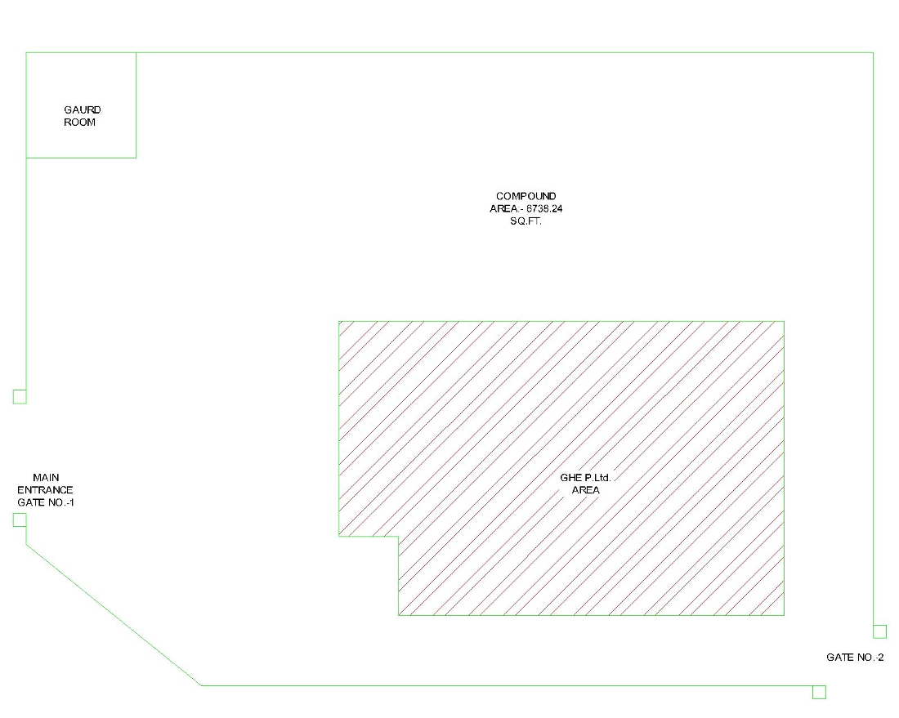

6. LIST OF PROJECT

6.1 Ongoing Projects

Buildings

- Design and construction supervision of Residential Building having 4.5 Floor at Fulbari, Boudha.

Hydro Power

- Construction Supervision of under-construction Shyam Khola Hydropower Project (7.20 MW), Bhojpur
District, – 2023
- Construction Supervision of under-construction Lower Chirkhwa Khola Hydropower Project (4.06MW), Bhojpur
District, – 2023
- Feasibility study of Ranma Khola Hydropower Project (30.2MW), East Rukum District – 2023
- Feasibility study of Dorpa Sapsup Khola Hydropower Project (4.30MW), Khotang District-2020
- Desk study of Lumsa Khola Small Hydropower Project (1.6 MW), Solukhumbu District – 2020
- Desk study of Dorje Khola Hydropower Project (0.96 MW), Ramechhap District – 2020
- Construction Supervision of under-construction Upper Chirkhwa Khola Hydropower Project (4.70MW), Bhojpur
District – 2019
Roads/Bridges

- N/A
Transmission Line
- Supervision work of 33kV transmission line of Upper Chirkhwa Khola HP (4.7MW), Bhojpur - 2022.

Software Development

- Development of website for Bhabya Construction Company
- Development of website for Neppower Company
- Development of website for North Summit Company
- Development of software “ GORKHA RESTRO “ - Restaurant Service software

6.2. Completed Projects
Magnetic Power Generation

- Detailed Project Repot of Magnetic Transducer Generator (MTG) Energy Generation Project (15.00MW), Bhaktapur District – 2020

Hydro Power

- Detailed design of Shyam Khola Hydropower Project (7.20 MW), Bhojpur District-2022
- Desk study of Ranma Khola Hydropower Project (30.2MW), East Rukum District – 2021
- Feasibility Study Report of Dana Khola Hydropower Project (34.80MW), Manang– 2020
- Preparation of Detailed Design of Upper Deumai Khola Small Hydropower Project (8.30MW), Ilam district-2020
- Detailed design & engineering of Lower Chirkhwa Khola Hydropower Project (4.06MW), Bhojpur District– 2019
- Feasibility study of Shyam Khola Hydropower Project (7.20 MW), Bhojpur District-2019
- Desk study report of Upper Sapsup Khola Hydropower Project (1.70 MW), Ramechhap District – 2019
- Desk study of Dorpa Sapsup Khola Hydropower Project (4.30MW), Khotangdistrict-2019
- Evaluation of Electromechanical works of Sapsup Khola Hydropower Project (6.6 MW), Khotang-2019
- Scoping Study, Detail Design & Construction supervision of Pung-pho MHP (15 kW), Chin State, Myanmar, 2018/19
- Scoping Study, Detail Design & Construction supervision of Muizawl MHP (15 kW), Chin State, Myanmar, 2018/19
- Scoping Study, Detail Design & Construction supervision of Donlui MHP (30 kW), Chin State, Myanmar,2018/19
- Detailed design& engineering of Sabha Khola-C Hydropower Project (4.55MW), Sankhuwasabha District-2018
- Feasibility study of Upper Deumai Khola Small Hydropower Project (8.30MW), Ilam district-2018
- Feasibility study of Palun-1 Hydropower Project (21.8MW), Taplejung district-2018
- Desk study of Shyam Khola Hydropower Project (7.20MW), Bhojpur district – 2018
- Feasibility study of Bajra Madi Hydropower Project (24.80MW), Kaski district-2017/18
- Desk study of Pokhara Seti Hydropower Project (23.3MW), Kaski district - 2017
- Feasibility study of SonaKhola Hydropower Project (5MW), Taplejung district-2017
- Feasibility study of SabhaKhola-C Hydropower Project (4.2MW), Sangkhuwasabhadistrict-2017
- Feasibility study of Palun Khola Hydropower Project (21MW), Taplejung district-2017
- Feasibility study of Middle Trishuli Ganga Hydropower Project (21.9MW), Nuwakot district - 2017
- Desk study Report of Dana Khola Hydropower Project (19.0MW), Manang– 2017
- Detailed design of Upper Chirkhwa Hydroelectric Project (4.70MW), Bhojpur district – 2016
- Working as a local Consultant to prepare FS Report for Sigma Engineering (Japan) for 7 different
- Hydropower Projects within Nepal. – 2015-2016.
- Feasibility Study of Lower Tara Khola HP Project, 3.5 MW, BaglungDistrict-2016
- Prefeasibility study of up to 26 numbers of Micro-hydro Projects under UN-Habitat program, Chin State, Myanmar-2017.
- Detail topographical survey and report preparation of Nalsingad Hydroelectric Projects (416MW), Jajarkot district – 2016 (sub consulting).
- Detail topographical survey at Budhiganga Hydropower Projects (20MW & 6MW) – 2016 (Sub consulting)
- Detail topographical survey at Myagdi Khola Hydropower Projects (32MW) – 2016 (Sub consulting)
- Detail topographical survey at Kaligandaki Khola Hydropower Projects (57MW) – 2016(Sub consulting)
- Desk study Report of Palun Khola -1 Hydropower Project (4.95MW), Taplejung - 2016
- Desk Study Report of Sabha Khola-C small HPP, 4.55 MW, Sangkhuwasabha District - 2016.
- Desk Study Report of Namili Khola Micro Hydro Project, 496 kW, Baglung District - 2016.
- Detail design and Supervision of Tara Khola Samudayik HPP (380KW), Baglung – 2016
- Detail Design and Engineering of Sano MiltiKhola Small Hydroelctric Project, 3.0 MW, RamechhapDistrict-2015
- Detail Design and Engineering of SabhaKhola-B Hydropower Project, 15.1 MW, SankhuwasabhaDistrict-2015
- Prefeasibility study of Jiri khola hydropower project (Storage Type), 2.40 MW, Dolkha - 2016
- Feasibility Study of Madhya Daram Khola B Hydopower Project, 4.2 MW, Baglung-2015
- Detail Design and Engineering of Middle Tara Khola Small Hydopower Project, 1.7 MW, BaglungDistrict-2015
- Redesign of Project Alignment & Review of Feasibility Study Report of Madhya Daram Khola“A” Small
- Hydropower Project, 3.0 MW, BaglungDistrict-2015.
- Detail Topographic and Bathymetry Survey at Powerhouse area of Lower Solu Hydroelectric Project, 82
- MW, Solukhumbu District-2015.
- Review of Feasibility Study Report of Lower Tara Khola Small Hydropower Project, 3.5 MW, BaglungDistrict-2015.
- Feasibility Study of Sano Milti Khola Small Hydroelectric Project, 3 MW, Ramechhap District- 2015
- Detail Feasibility Study of Middle Trishuli Ganga NadiHP, 55 MW, NuwakotDistrict-2015
- Review of Detail Design and Engineering of Chulepu Khola Hydropower Project, 8.52 MW, RamechhapDistrict-2015
- Geological/ Engineering Geological Study of Thadekhani Khola Small Hydropower Project, 3 MW, Myagdi District- 2014
- Geological/ Engineering Geological Study of Sanigad Khola Micro- Hydro Project, 100 KW, Bajhang District- 2014
- Preparation of Desk Study Report of Butterfly Hydropower Project-Storage Type, 8.40
- MW,RamechhapDistrict-2014
- Feasibility Study Report of Madhya Daram Khola “A” Small Hydopwer Project, 3.0 MW, Baglung District -2014.
- Detail Feasibility Study Report of Middle Tara Khola Hydroelectric Project, 1.7 MW,Baglung District-2013.
- Desk Study Report of Madhya Daram KholaA Small Hydopwer Project, 3.0 MW, Baglung District - 2068.
- Desk Study Report of Madhya Daram Khola B Small Hydropower Project, 4.2 MW, BaglungDistrict-2068.
- Desk Study Report of Middle Tara Khola Hydroelectric Project, 1.7 MW,BaglungDistrict-2068.
- Feasibility Study of Dorje Khola Hydropower Project,1.0 MW, Ramechhap District - 2012.
- Review and upgrading Report of Upper Hewa Khola HP, 12 MW, Panchthar District - 2012.
- Survey, design and construction supervision of various micro-hydro Projects with 5KW to 100KW in different location of Nepal.
Roads/Bridge

- Survey and preparation of as built drawing for Access road of Likhu HPP (25km), RamechhapDistrict - 2018
- Consultancy services for topographical survey of Mugu-Humla Link Road –RAP3 (32km), HumlaDistrict-2017.
- Access Road from Ferry at ArunKhola to Forebay of Lower Chirkhwa HPP (4.0km), Bhojpur – 2017.
- Detail survey and design of access road (51km) of KasuwaKhola Hydropower Project, 45 MW, SankuwasabaDistrict-2016.
- Survey and design of Access road of SKBHPP-15.1MW, sankuwasabhaDistrict - 2016
- Access Road From Sare Mod To Adit1 Lower SoluKhola Hydropower Project, 82 MW, Tingla-4, SolukhumbuDistrict - 2015
- Detail Survey and Design of Access Road of Sano MiltiKhola Small Hydroelectric Poroject,5.0 KM, RamechhapDistrict-2015
- Detailed Survey and Design of Kantilokpath Road Jeetpur Bhangyang To Kalo Paharo, 11 KM, MakawanpurDistrict-2015
- Survey and Detail Design of Sahid Marga Road Project, 32.20 Km, RolpaDistrict-2014
- Survey and Detail Design of Middle Trishuli Ganga Nadi HP Access Road- 12 KM,NuwakotDistrict-2014
- Quantity Calculation and preparation of Final Bill of Chulepu Khola HP Access Road -43 KM, RamechhapDistrict-2014
- Survey and planning of entire road and buildings of Sunrise Homes, Balkumari, LalitpurDistrict. - 2013.
- Survey, Design & Construction Supervision of Entire link Road of Sunrise Homes, Balkumari, Lalitpur. -2013.
- Survey, Design & Construction Supervision of Access Road of Tadi Khola HP, Nuwakot. 4.5 MW - 2012.

Transmission Line
- Route Survey and Design of 33kV transmission line of Solar PV Project (6.8MW), Morang- 2021.
- Route Survey and Design of 132kV transmission line of Dana Khola HPP (34.80MW), Manang- 2019.
- Route Survey and Design of 33kV transmission line of Upper Chirkhwa HPP (4.7MW), Bhojpur- 2018.
- Desk Study of 132kV transmission line of Bajra Madi Hydropower Project (24.8MW), Kaski-2017
- Route Survey and Design of 33kV transmission line of Rawa Khola HPP (6.5MW), Khotang - 2017.
- Route Survey and Design of 33kV transmission line of Middle Tara Khola HEP (1.7MW), Baglung - 2016.
- Desk Study of 33kV transmission line of Sano Milti Khola Small Hydroelctric Project, 3.0 MW, Ramechhap.
- Route Survey and Design of 33kV transmission line of Milti Khola HPP (5MW), Ramechhap - 2015.
- Route Survey of 33kV Transmission line having length of 10.4km of Buku Khola HPP
- Route Survey and Design of 132kV transmission line of MTGHPP (55MW), Nuwakot - 2015.
- Route Survey and Design of 11kV transmission line of Dorje Khola Hydropower Project,1.0 MW - 2012.

Solar Project

- Preparation of DD Report for NMB Bank– 2022

Buildings

- Renovation and construction supervision of Residential Building at Ekantakuna– 2019
- Design and supervision of 2.5 storied residential building , Balaju-2018
- Retrofit design and supervision of 2 storied residential building, Swoyambhu-2018
- Retrofit Design and supervision of 4-storied private building at Basantapur - 2017
- Retrofit Design and supervision of 4-storied private existing building at Boudha – 2017.
- Design and Estimating of residential building at Baneswor Height (3-storied), Kathmandu- 2016
- Design, supervision for renovation & retrofit works of Residantial Works at Raniban, Kathmandu-2015.
- Design, supervision for renovation & retrofit works of Residantial Works at Kausaltar ,Bhaktpur-2015
- Design/ Drawing and Prepn of BoQ of Lopsang Sherpa Gumba ( 4 storied), Chabahil, KTM-2015
- Design and supervision for renovation & retrofit works of Factory Building at Jorpati, Kathmandu-2015
- Design and supervision for renovation & retrofit works of Residental Building at Balaju, Kathmandu-2015
- Design & supervision for renovation & retrofit works of Factory Building at Thaiba, Bhaktpur-2015.
- Design and Preparation of BoQ of Dhapasi Residential Building(2 ½ storied), Dhapasi, KTM-2014
- Design & Construction Supervision of Kapan Residential Building (4 storied), Kapan, Kathmandu - 2012.
- Design & Construction Supervision of Balkot Residential Building (3 storied), Balkot, Bhaktapur– 2012
- Design, Estimate & preparation of structural of drawing for retrofit works of different structures in California, USA (5 years).
Software

- Development of software “ACSYS 2020” - Accounting package
- Development of software “HYDROSOFT” - Design software for Hydro power design.
- Development of website “ lcenergypvtltd.com “ - Hydropower Company website
- Development of website “ capconexperts.com “ - Investment Company website
- Development of website “ srpnirmansewa.com “ - Construction Company website

7. ORGANIZATIONAL STRUCTURE OF THE COMPANY

The organization of the company consists of Board of Directors, Chairman and Managing Director Supported by experienced and well-qualified personnel, advisors, engineers, and planners of different disciplines. The shape and size of the organization may vary as per the need of the project's nature and size. To conduct regional works, branch office has been established in Narephant, Kathmandu. Besides this there are other technical and administrative personnel serving either as full time or part time basis. Number of personnel may be increased when required by the project without affecting the structure model of the organization.

8. ORGANIZATIONAL CHART

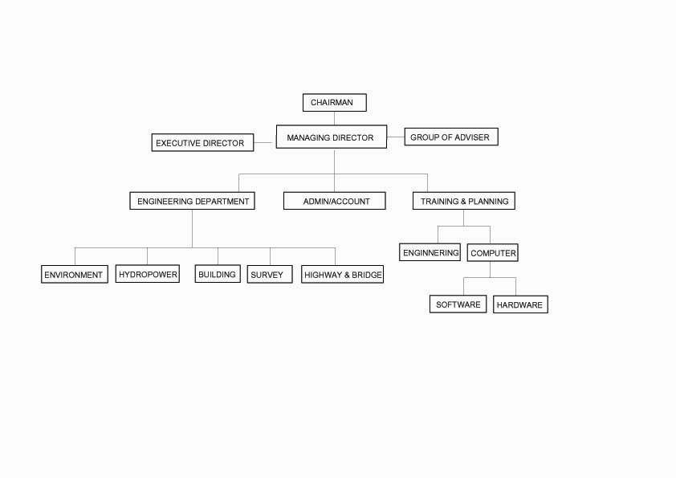

11

9. KEY PERSONNEL WITH THEIR ACADEMIC QUALIFICATION AND YEAR OF EXPERIENCE

A. Full time Staffs
S.N. Name Position Education Year of Experience I. Executives
• B.B. Bardeuli (Rai) | Chairman | BE (Civil) | 37
• Biswo. Shrestha | Managing Director | M.Sc.(Hydropower ) | 25
• A. P. Nepal | Executive Director | M.Sc. (Bridges & Tunnel) | 327

II. Software Department

• Pramod Thakur System Engineer B.CA (Computer Science) 10
• Eugene Shrestha Software Engineer B.CS (Computer Science) 2
• Keshab Saud Software Engineer 2
• Nitesh Rai Software Engineer 3
• Sumanta Shrestha Software Engineer 2

III. Engineering Department

• Dawajangmu Shrestha Sr. Hydrpower Engineer M.Sc. (Hydropower) 25
• Nabina Rai Planning/Contract Engineer M.Sc (Construction Management) 9
• Ramesh Sapkota Electrical Engineer M.E (Electrical) 6
• Sambay Rai Civil Engineer B.E (Civil) 3
• Rinki Bhattarai Civil Engineer M.E (Civil) 5
• Lhenjam Mingzon Civil Engineer B.E (Civi) 1
• Khagendra Dev Civil Engineer B.E (Civil) 8
• Pankaj Kumar Dev Civil Engineer Civil 15
• Baiju Dev Jr. Er. Diploma (Civil) 6
• Devid Chaudhari Mechanical Engineer B.E (Civil) 5
• Namnit Kumar Sah Mechanical Engineer. B.E 3

IV. Account/Administration Department

• Umesh Magar Accountant B.A 6
• Nirmal Shrestha Accountant I.A. 2
• Arati Mahato Accountant I.A. 1

• Kamala Rai Office Assistant SLC 11
• Sabitri Shrestha Office Helper SLC 2

B. Part time/ Freelance/Contract Staffs

• Prakash Shrestha Financial Analyst Ph. D. (Finance) 12
• Sabin Bhandari Hydrologist M.Sc.(Hydrology) 8
• NirmalKafle Engineer Geologist M.Sc in Geology 9
C. Group of Advisors

• S.R.Shrestha Sr. Environmental Engineer ME (Environment) 50
• Pahad Shrestha Sr. Structural Engineer M.Sc (Structure) 34
• Dr. N.B. Shrestha Sr. Structural Engineer Ph. D (Structure) 25

10. LOCATION MAP OF OFFICE:

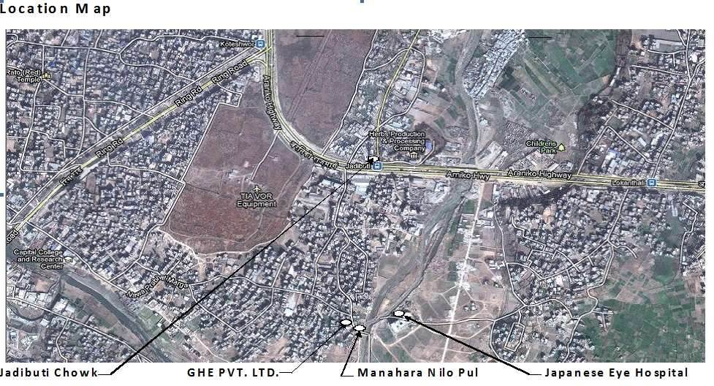

ANNEXE-I (Company Registration Certificate)

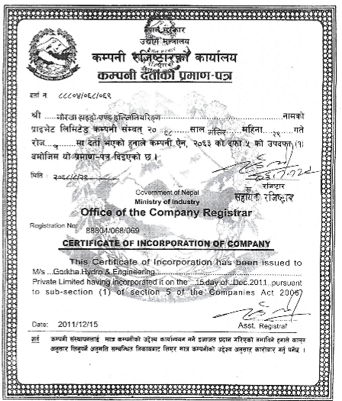

ANNEXE-II VAT Registration Certificate
